EXTENDED ABSTRACT TITLE

First Author1, Second Author*2 and Third Author3 (Full Name)

^{1,} ² Authors’ Department, Institute, City, COUNTRY.
(E-mail: firstauthorsname@aaaa.bbb, *secondauthorsname@aaaa.bbb)
³ Author’s Department, Institute, City, COUNTRY.
(E-mail: thirdauthorsname@aaaa.bbb)

ABSTRACT

The abstract should be written in 10-points Times New Roman and should not be more than 200 words each. The abstract should not only indicate the subject and scope of the paper but also summarize the author’s conclusion. The structured abstract must be a brief, comprehensive summary of the contents of the article. It allows readers to survey the contents of an article quickly. An Abstract summarizes the major aspects of a paper. It should succinctly summarize the purpose of the paper, the methods used, the major results, and the conclusions.

Keywords: Keyword 1, Keyword 2, Keyword 3 (Min 3 keywords & Max 5 keywords)

INTRODUCTION

We expect that authors will follow some simple guidelines. In essence, you should format your paper exactly like this document. For writing the extended abstract the authors can download this template and replace it with their content.
In this section, the author should address the the background and objectives of the research.

The extended abstract should be written in MS Word format in single-spaced 12-point Times New Roman except for the abstract. Do not indent the text paragraphs. Each paragraph must be single-spacing separated

MATERIAL AND METHODS

Please briefly explain the aim and scope of the study, the materials and methods, and the main findings and a brief analysis of the study.
Authors are requested to submit the Extended Abstract (maximum of 3 pages in length, including the references and pages should not be numbered) in electronic form (MS-Word) via our Online Submission. The incorrect formats may result in your abstract being returned to you by e-mail for correction. The scientific committee will select the contributions for oral and poster presentations.

RESULTS
In this section, the author should address the findings and discussion. Figures can be included in your extended abstract and referred to in the text. Please ensure that the figure and caption are inserted in the text box provided below. Please observe Figure 1 and Table 1 to include figures and tables in the manuscript, respectively. The in-text citation of the manuscript should be in APA reference style only [Parenthetical citation: (Grady et al., 2019); Narrative citation: Grady et al. (2019)].

Figure 1. Example of figure for the extended abstract
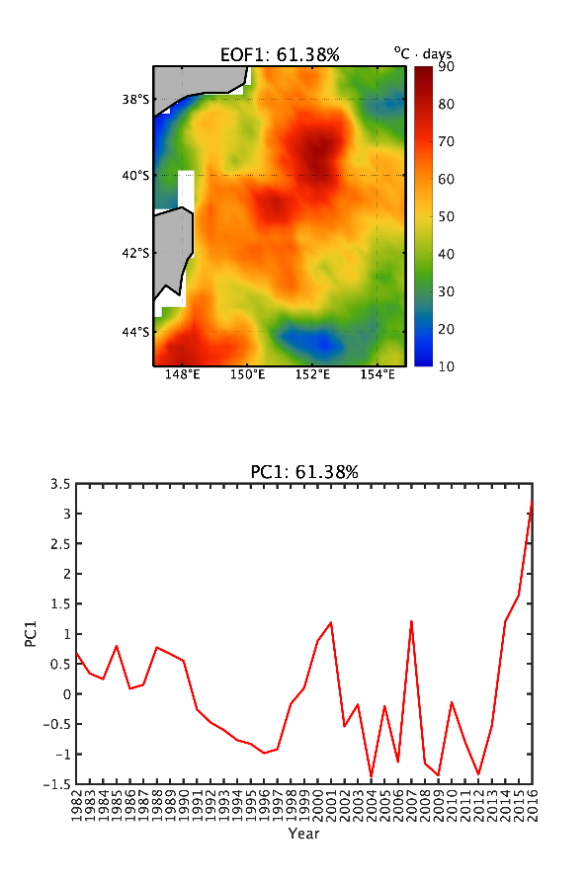

Figure 2. Example of figure for the extended abstract

A table should be inserted like the one below and referred to in the text. Please avoid vertical rules and shading in table cells.

Table 1. Example of table for the extended abstract

Contents of Table
- Xxxx 0000
- Yyyy 0000
- Zzzzz 0000

A maximum of one table and two figures are allowed.

CONCLUSION

The conclusion is intended to help the reader understand why your research should matter to them after reading the paper. A conclusion is not merely a summary of the main topics covered or a re-statement of your research problem but a synthesis of key points and, if applicable, where you recommend new areas for future research.

Acknowledgment: The authors would like to express their appreciation for the support of the sponsors with Project No xxxx funding details etc.

REFERENCES (APA Style)

Grady, J. S., Her, M., Moreno, G., Perez, C., & Yelinek, J. (2019). Emotions in storybooks: A comparison of storybooks that represent ethnic and racial groups in the United States. Psychology of Popular Media Culture, 8(3), 207–217. https://doi.org/10.1037/ppm0000185 (Journal)

Hygum, E., & Pedersen, P. M. (Eds.). (2010). Early childhood education: Values and practices in Denmark. Hans Reitzels Forlag. https://earlychildhoodeducation.digi.hansreitzel.dk/ (Book)

Aron, L., Botella, M., & Lubart, T. (2019). Culinary arts: Talent and their development. In R. F. Subotnik, P. Olszewski-Kubilius, & F. C. Worrell (Eds.), The psychology of high performance: Developing human potential into domain-specific talent (pp. 345–359). American Psychological Association.
https://doi.org/10.1037/0000120-016 (Book Chapter)

